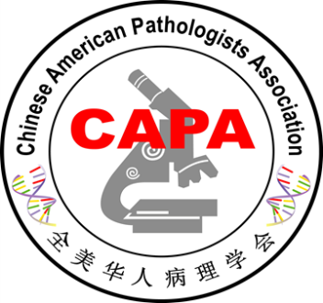
2018 CAPA Annual Meeting Best Abstract Awards
Group 1: USCAP Platform
This group included abstracts accepted for USCAP Platform Presentation
First Place:
Dr. Liwei Jia; Memorial Sloan Kettering Cancer Center, NY
Title: Morphologic and Molecular Characterization of Renal Medullary Carcinoma: A study of 18 cases
Second Place:
Dr. Hong Fang; Mayo Clinic, MN
Title: Chronic Lymphocytic Leukemia (CLL) with Immunoglobulin Heavy Chain Gene (IGH)-BCL3 Translocation Exhibits a More Aggressive Clinical Course
Dr. Kwun Wah Wen; University of California San Francisco, CA
Title: “Indefinite for Dysplasia” in Inflammatory Bowel Disease: Aneuploidy as a Diagnostic and Prognostic Marker of High-Grade Dysplasia or Colorectal Cancer
Third Place:
Dr. Xin He; Brown University, RI
Title: Validation of Alternative Pre-Stained Cytology Specimens for a Clinical Next-Generation Sequencing Assay
Dr. Dongwei Zhang; University of Florida College of Medicine, FL
Title: Histologic patterns of anti-PD-1 therapy-induced liver injury

Group 2: GoPath Diagnostics Award (USCAP Poster)
The group included abstracts accepted for USCAP poster presentation. Award sponsored by GoPath Diagnostics
First Place:
Dr. Shuo Xu; Queen’s University, ON, Canada
Title: PAX5/PD-1 Double Staining: A Useful Tool in Aiding the Diagnosis of Angioimmunoblastic T-Cell Lymphoma
Second Place:
Dr. Xiaoyan Liao; Icahn School of Medicine at Mount Sinai, NY
Title: Clinicopathological and Molecular Characterization of Crohn’s Disease-Associated Small Intestinal Adenocarcinomas
Dr. Jian Shen; University of Rochester, NY
Title: Quantitative measurement of Human Epidermal growth factor Receptor-2 (HER2) protein expression in ‘classical’ and ‘non-classical’ FISH categories: a comparative study.
Third place:
Dr. Zhichun Lu; Henry Ford Health System, MI
Title: Expression Profiles of ERG, SPINK1, ETV1 and ETV4 in Early Onset Prostate Cancer: An Immunohistochemical and RNA In-Situ Hybridization Study on Whole Mount Slides
Dr. Fei Chen; New York University, NY
Title: Non-malignancy pathologic findings and their clinical significance on targeted prostate biopsy in men with PI-RADS 4 / 5 lesions on prostate MRI
Dr. Lin Zhang; University of Texas McGovern Medical School, TX
Title: Tumor Infiltrating Lymphocyte Volume is a Better Predictor of Neoadjuvant Therapy Response in Triple Negative Breast Cancer
Group 3: CAPA new abstracts
The group included new abstracts submitted for CAPA annual meeting.
First place:
Dr. Zhongbo Jin; University of Florida, Gainesville, Florida
Title: Desmoplasia and Detached Papillae: two Unrecognized Histologic Features of Esophageal Adenocarcinoma
Second place:
Dr. Fengming Chen: Penn State Health Milton S. Hershey Medical Center, Hershey, PA
Title: Detection of Cytomegalovirus in Inflammatory Bowel Disease: A Retrospective Study
Dr. Hongbo Wang; Baylor Scott & White Medical Center, Texas A & M University, TX
Title: A Single Institute Experience in Diagnosing Parathyroid Lesions in Ultrasound Guided Thyroid FNA
Third Place:
Dr. Diana Dai; Brody School of Medicine at East Carolina University, NC
Title: Low Prevalence of Hemoglobin G-Philadelphia in Eastern North Carolina: Series of Seven Cases in the Past 48 Years and Literature Review
Dr. Hongjie Li; SUNY Downstate Medical Center, Brooklyn, New York
Title: Global levels of Histones H3K18 and H4K16 Acetylation in Pancreatic Adenocarcinoma
Dr. Zheng Ping; University of Alabama, Birmingham, , AL
Title: Lower rate of perineural invasion may correlate with better long term survival of ampullary carcinoma.

CAPA Award Committee
Vancouver, BC, Canada, March 17, 2018

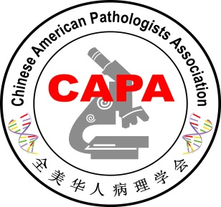
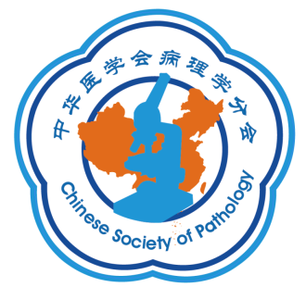
The 4th Annual
Chinese-American
Pathology Symposium

Best Abstract Award
Sponsored by Motic

First Place:
Dr. Wenyi Jing; Department of Pathology, West China Hospital, Sichuan University, Chengdu, Sichuan
Title: Amplification of FRS2 in Atypical Lipomatous Tumor/Well -Differentiated Liposarcoma and Dedifferentiated Liposarcoma：a Clinicopathological and Genetic Study of 146 Cases
Second Place:
Dr. Tian Tian; Department of Pathology, Fudan University Shanghai Cancer Center, Shanghai
Title: Evaluation of the BRCAness phenotype and its correlations with clinicopathologic features in triple-negative breast cancers
Dr. Yaoxing Xiao; Department of Pathology, Fudan University Shanghai Cancer Center, Shanghai
Title: DICER1 hotspot mutation in ovarian Sertoli-Leydig cell tumors
Third Place:
Dr. Lulu Rong; Department of Pathology and Resident Training Base, National Cancer Center/Cancer Hospital, Chinese Academy of Medical Sciences and Peking Union Medical College, Beijing
Title: Prognostic significance of extracapsular lymph node involvement following esophagectomy for esophageal squamous cell carcinoma in Chinese patients
Dr. Ruohong Shui; Department of Pathology, Fudan University Shanghai Cancer Center, Shanghai
Title: Hormone receptor and human epidermal growth factor receptor 2 status in invasive breast carcinoma: A retrospective study from 19 Chinese representative clinical centers
Dr. Joe Yeong; Department of Anatomical Pathology, Singapore General Hospital, Singapore
Title: Quantitative imaging and deep profiling of collagen structure in Asian triple negative breast cancers: novel perspectives of the breast cancer micro-environment

CAPA Award Committee
Vancouver, BC, Canada, March 17, 2018

