The Report for 2018 CAPA annual meeting at USCAP, Vancouver, Canada

This meeting consisted the scientific portion, co-hosted with Chinese Society of Pathology (CSP) at the 4th Chinese-CAPA pathology symposium, and CAPA annual business meeting. A record of about 300 people attended this meeting, among them about 100 pathologists from China and about 200 CAPA members from North America.

**4th Chinese-CAPA Pathology Symposium**

1) Poster presentation

Over 70 posters participated this presentation, everyone received a certificate of "Appreciation of Participation"**. Participates from China are**: Yanhua Bai, Min Bao, Jietian Jin, Wenyi Jing, Xiaoying Lou, Peihong Shen, Yunfei Shi, Peng Sun, Julun Yang, Joe Yeong, Jingping Yuan, Lirong Zhang, Yanlin Zhang, Danyang Zheng, Raohong Shui**. Participates from US and Canada are:** Hong Jiang, Li Lei, Hongbo Wang, Lin Zhang, Haiying Zhan, Shuo Xu,Jian Shen, Xinyu Wu, Ding Dai, Dongwei Zhang, Hong Fang, Xiaoqin Zhu, Jia Xu, Zhichun Lu, Lijun Xue, Kevin Ren, Haoliang Xu, Xin He, Xiaoyan Liao, Rong Xia, Wei Xie, Yansheng Hao, Guofeng Gao, Tong Sun, Li Chen, Kwun Wah Wen, Fei Chen, Liwei Jia , Xiang Xu, Yaohong Wang, Zheng Ping, Di (Andy) Ai, , Hongbo Wang, Xi Zhang, Yiang Hui, Haoliang Xu, Hongxing Gui, Hongjie Li, Zhongbo Jin, Yan Liu, Guofeng Gao, Xin Zhang, Diana Dai, Tiannan Wang, Hong Jiang, Fengming Chen, Li Liang, Shuhua Ma.

About 10 on site judges from US and China (including Drs. Yun Gong, Hanlin Wang, Huanyou Wang, Charles Guo, Beiyun Chen, Beverly Wang, Xiaohuan, Qian Zenggang Pan, Linsheng Zhang, Wenxin Zheng) selected 23 top abstracts for 4 categories of awards. These awards were presented by Dr. Hong Bu, President of CSP; Dr. Linsheng Zhang, Chair of CAPA Award Committee, and representatives from our sponsors - GoPath and Motic. Please see the separate report for list of recipients of these awards.

2) Subspecialty Session on Breast Pathology

Four leading experts on breast pathology , including Dr. Wentao Yang (Fudan University Cancer Center, China), Dr. Gary Tse (Hong Kang Chinese University, China), Dr. Ian Ellis (University of Nottingham, England), and Dr. Puay Hoon Tan (Singapore General Hospital, Singapore) gave excellent talks on recent development in breast pathology. This session is the highlight of the this meeting, with 150 audiences packing the entire conference room, including the past president of Japanese Society of Pathology. A fifteen 15min question and answer session following the lectures also generated a great discussion.

**CAPA Annual Business Meeting:**

Dr. Ping Tang gave her president's report for last year's work by each CAPA committee (please see separate President Annual Report). Dr. Bianxiu Wu, president of China IAP, summarized the history of the collaboration between CAPA and CSP; Dr. Jie Chen, president of Chinese Quality Control Association for Anatomic Pathology introduced the current quality control improvement in China; and Dr. Bruce Williams, president of CAP, wished more success for CAPA and better collaboration between CAPA and CAP.

This year, five individuals, because of their significant contribution to CAPA and to our Pathology Community, have received CAPA's top awards. They are Patrick E. T. Godbey for CAPA Honorary Award; Dr. Julun Yang for CAPA President's Award; Dr. Zu-hua Gao and Dr. Liang Cheng for CAPA Distinguished Pathology Award and Dr. Zongming Eric Chen for CAPA/Zu-Hau Gao Outstanding Service Award.

The CAPA Member of the Year Award went to five outstanding members with significant contribution during last year. They are Dr. Songqing Zhao, Dr. He Wang, Dr. Jie Song, Dr. Ximin Yang and Dr. Fan Chen. Also, many other CAPA members have volunteered countless hours of their free time for CAPA activities, they were the awardees for CAPA Appreciation Awards: Xiaoqi Lin, Helen Chen, Chunhua Cui, Chen Zhou, Xiaoping Sun, Shuyuan Xiao, Xianzhong Ding, Zenggang Pan, Yaxia Zhang, Hong Jiang, Yanxia Li, Guilan Chen, Wei Zhang , Xiuli Liu, Qingqing Ding, Lee-Chin Zhu, Fang Qian, Chunhau Cui ,Xin Han, Ziwei Ma, John Guo, Marilyn Bui, Huihong Xu. Xiaoji Lin, Ximing Yang, Xinmin Zhang, Chengquan Zhao, Jack (Xu) Yang, Yaxia Zhang, Wenqing Cao, Hua Yang, Shuyue Ren, Rohn Fann; Charles Guo, Zaibo Li, Jinming Song, Hailing Zhang, Xiaohui Zhang, Lijuan Wang; Linsheng Zhang, Guoli Chen, Shunyou Gong, Changqing Ma, Limin Yu, Xuchen Zhang, Jiehao Zhou, Haiyan Chen, Jia Ye, Mujun Yu, Shuyuan Xiao, Chin-Lee Wu, Shuan Li. Rouqing Huang

President-elected Dr. Yun Gong presented the new CAPA leadership team for 2018-2019 and her version for the coming year. Two speakers from Leica and Foundation Medicine also gave a short presentation. A group picture were taken by Dr. Xiaoping Sun and about 300 people attended the evening Banquet at Victoria Chinese Restaurant, Vancouver.

It has been an remarkable year me and the entire team of EC. We have an extremely successful year, and together we have made the history for CAPA. Without all of you, none of these are possible. Thank you all from the bottom of my heart. Also, many thanks for Dakewe and Leica Shanghai, who have generously sponsored this meeting.

Ping Tang, MD, PhD

CAPA President 2017-2018

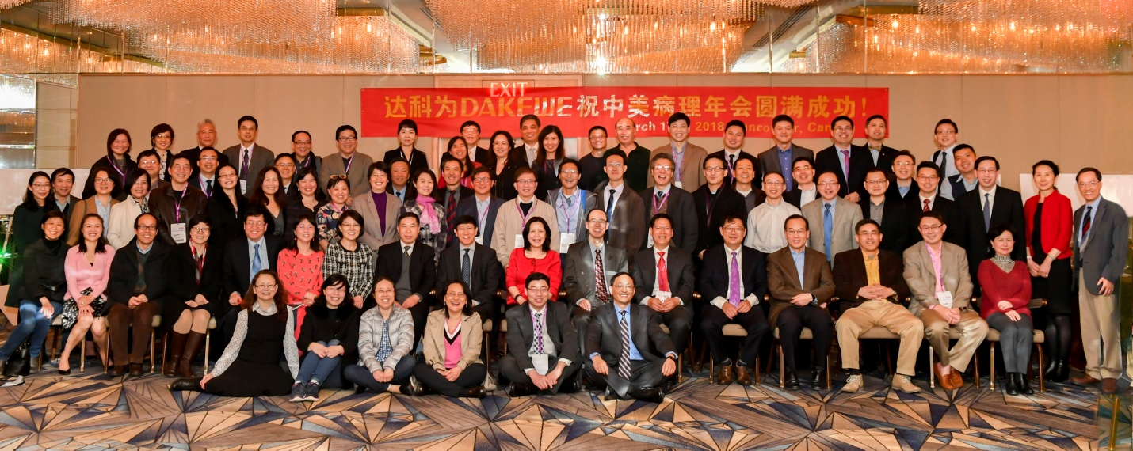

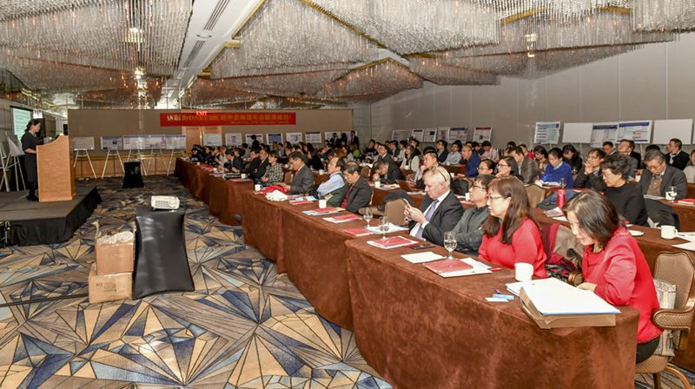

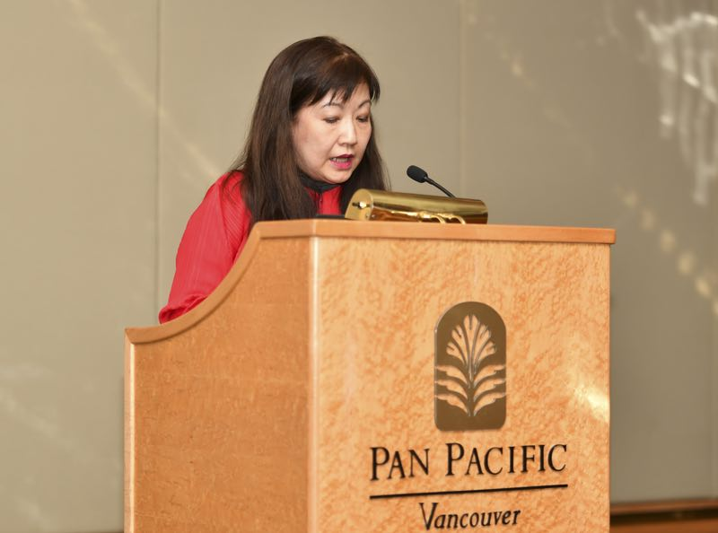 Dr. Puay Hoon Tan

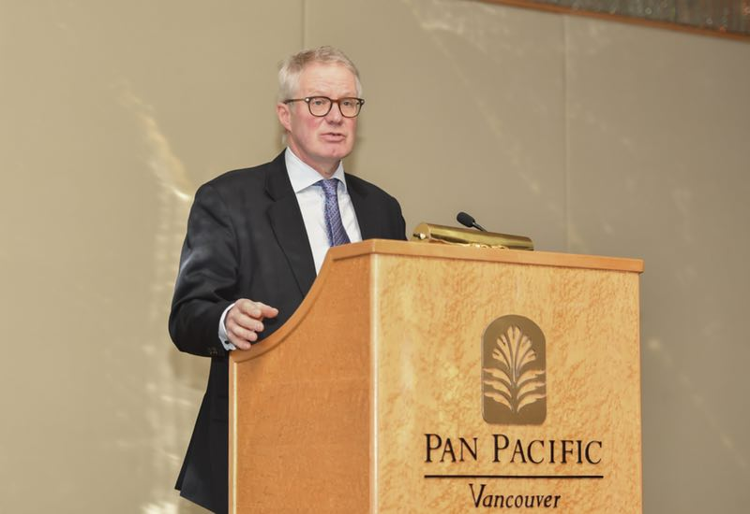 Dr. Ian Ellis

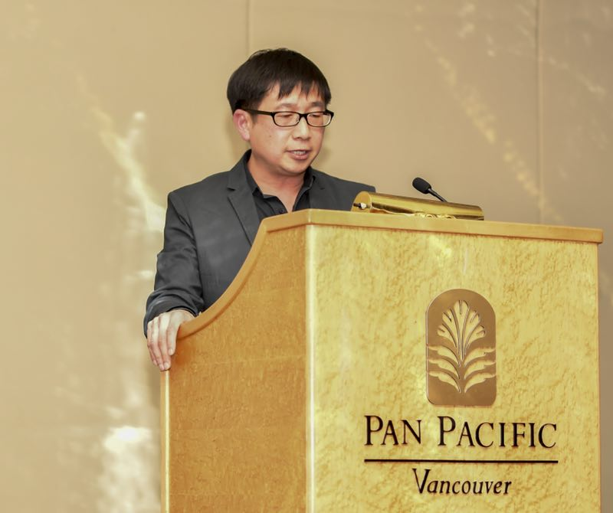 Dr. Gary Tse

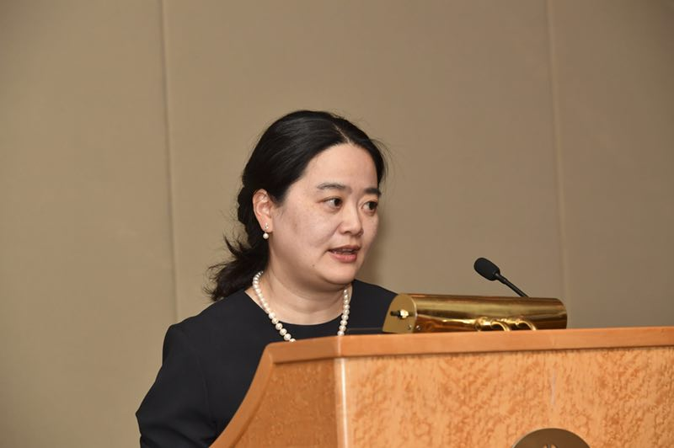 Dr. Wentao Yang

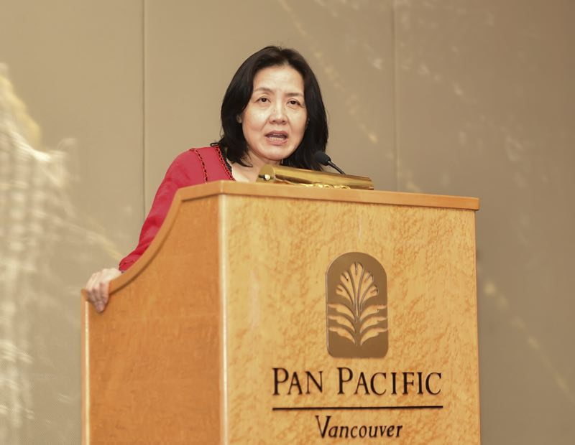 Dr. Ping Tang

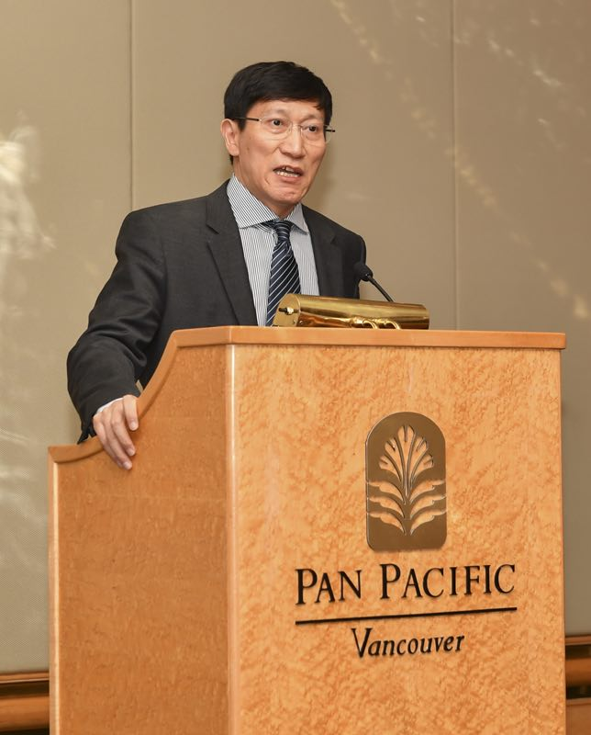 Dr. Bianxiu Wu

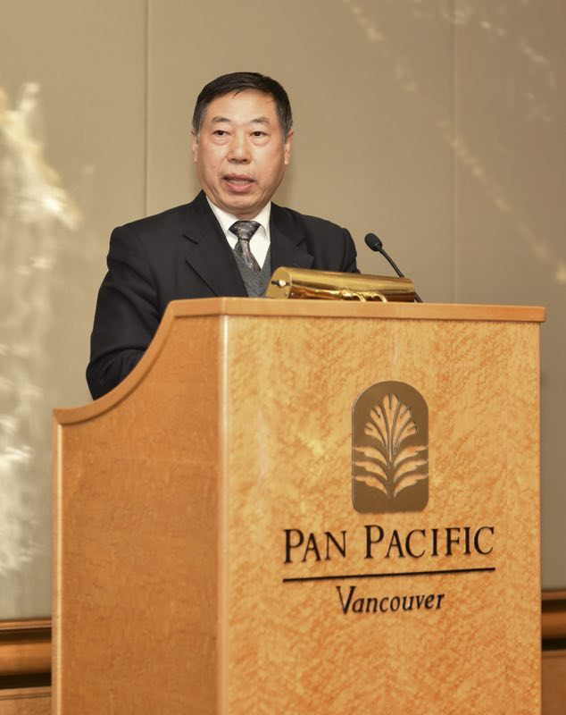 Dr. Jie Chen

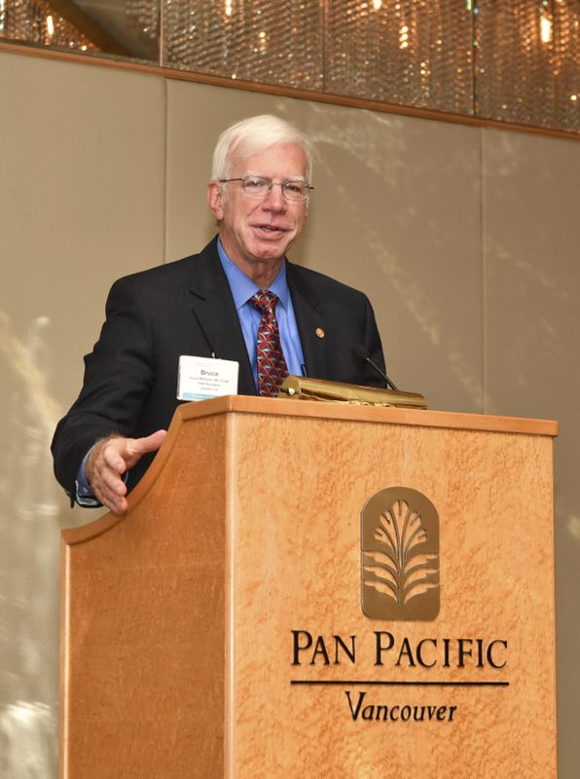 Dr. Bruce Williams

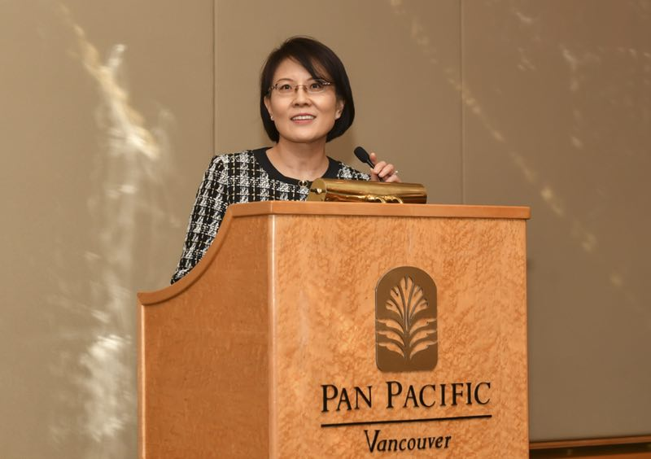 Dr. Yun Gong

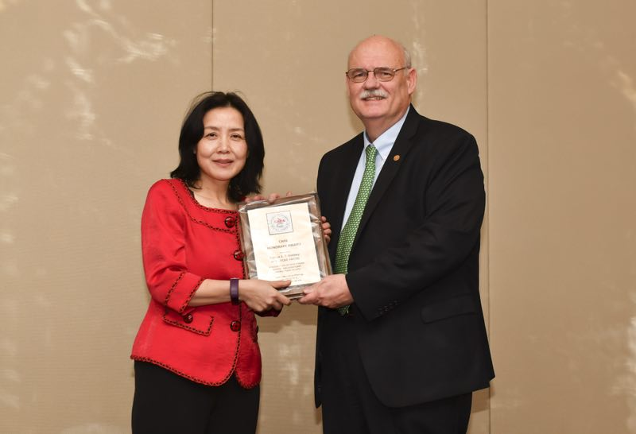 Drs. Ping Tang and Dr. Patrick Godley

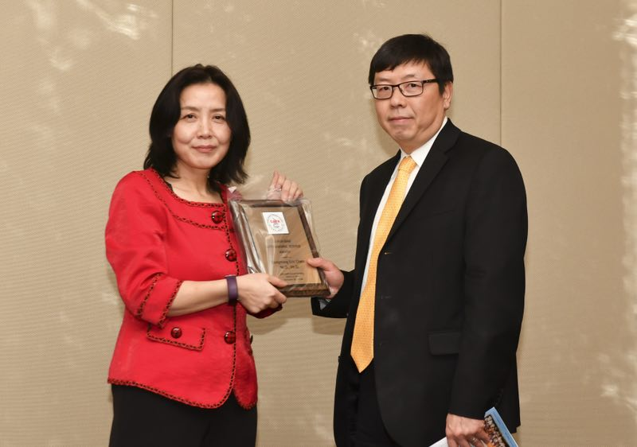 Dr. Ping Tang and Dr. Eric Chen

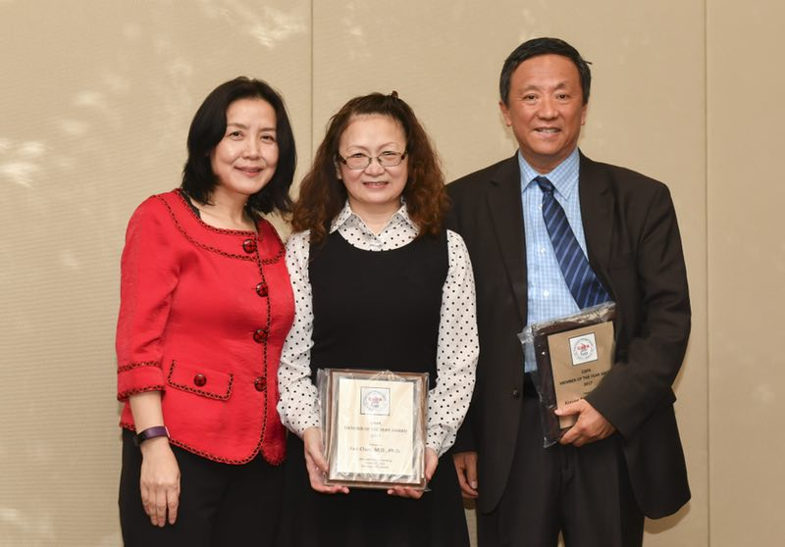 Drs. Ping Tang, Fan Chen, Ximing Yang

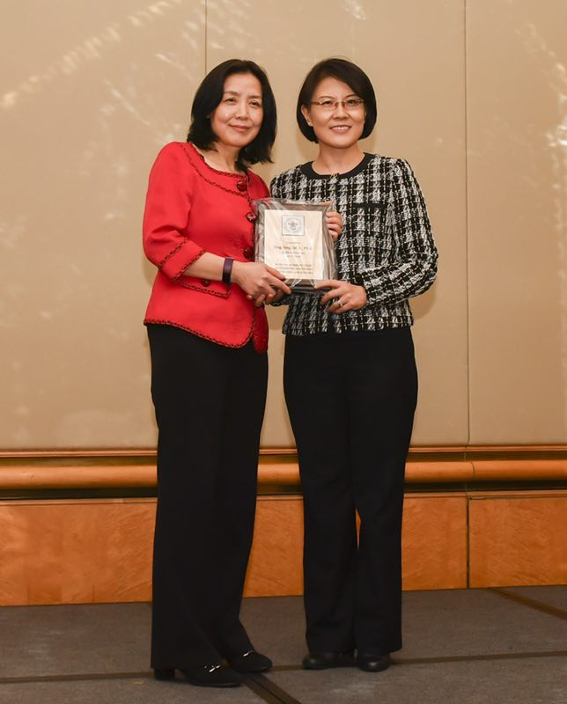 Dr. Ping Tang, Dr. Yun Gong

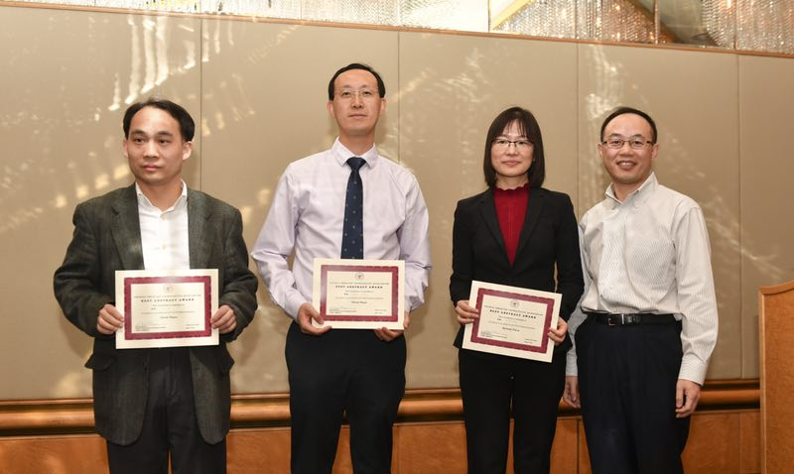 Awardees for CAPA Best Abstracts-Platform

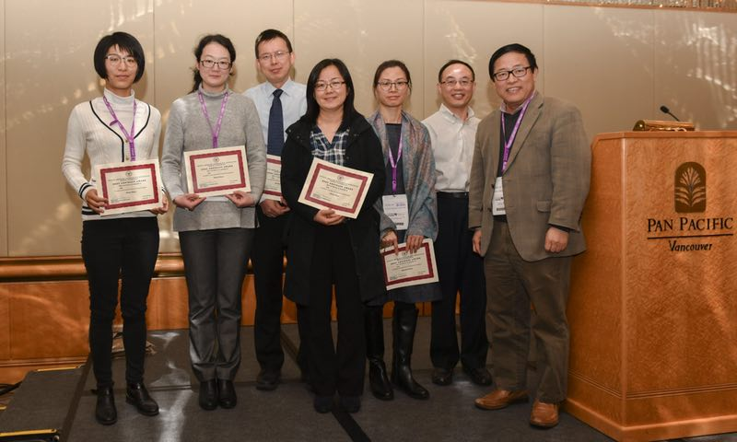 Awardees for CAPA-GoPath Award

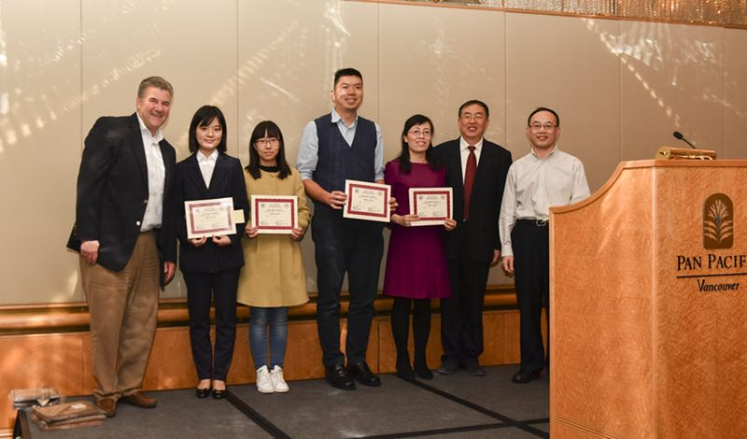 Awardees for CSP-CAPA awards

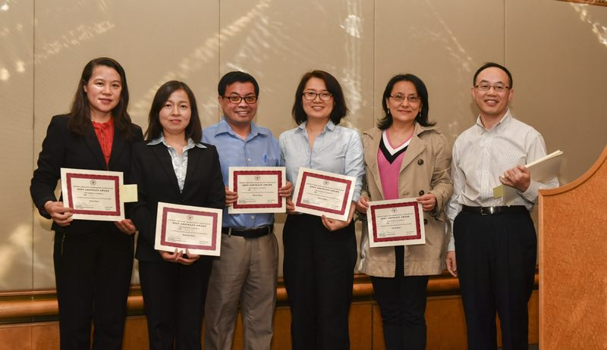Awardees for best new abstracts

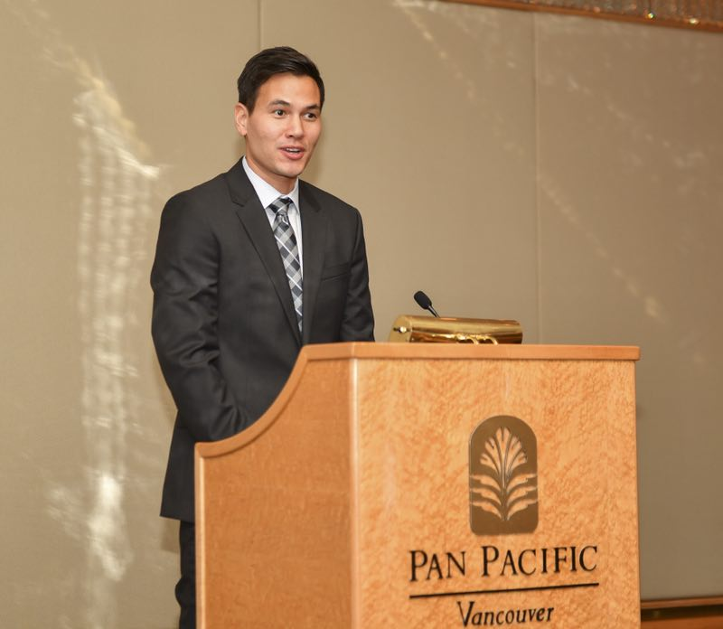 Representative from Leica

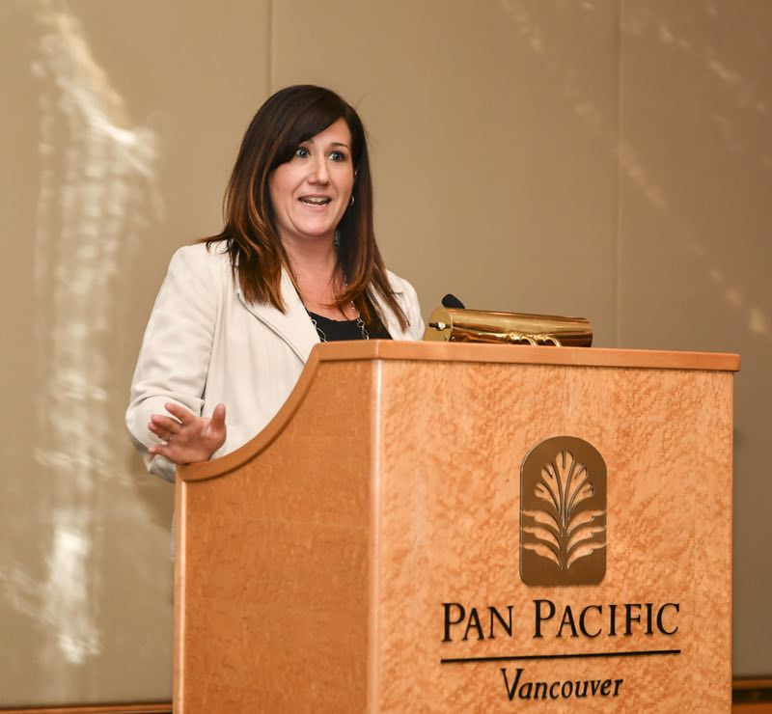 Representative from Foundation Medicine